HTML Document

📄 Definition
# Source: AI Source: Provided by: [Data Path: Persons Table -> ID Column: 1, Name_En Column: Motasem Essam] -> From: [ChatGPT] on [5/6/2026]
An HTML document is a file written in HTML (HyperText Markup Language) that defines the structure and content of a web page.
It tells the browser what to display and how to organize it (text, images, links, forms, etc.).

🗂️ What is an HTML File?
# Source: AI Source: Provided by: [Data Path: Persons Table -> ID Column: 1, Name_En Column: Motasem Essam] -> From: [ChatGPT] on [5/6/2026]
An HTML file is a text file that contains HTML code and is used to create a web page.
- It always ends with .html (for example: index.html)
- It can be opened in any web browser
- It contains tags that structure the page

🛠️ What is an HTML Editor?
# Source: AI Source: Provided by: [Data Path: Persons Table -> ID Column: 1, Name_En Column: Motasem Essam] -> From: [ChatGPT] on [5/6/2026]
An HTML editor is a program used to write and edit HTML code.
Popular HTML Editors:
- Notepad → Simple and basic (good for beginners)
- Visual Studio Code → Powerful and widely used
- Notepad++ → Lightweight with extra features
- Sublime Text → Fast and clean interface
What does an editor do?
- Lets you write HTML code
- Highlights code with colors (syntax highlighting)
- Helps find mistakes
- Makes coding easier and faster •

What is an Index File?
# Source: AI Source: Provided by: [Data Path: Persons Table -> ID Column: 1, Name_En Column: Motasem Essam] -> From: [ChatGPT] on [5/6/2026]
An index file (usually named index.html) is the main or default webpage of a website.

When you visit a website like:
www.example.com

The browser automatically looks for:
index.html

and opens it first.

🧱 Structure of an HTML document
# Source: AI Source: Provided by: [Data Path: Persons Table -> ID Column: 1, Name_En Column: Motasem Essam] -> From: [ChatGPT] on [5/6/2026]
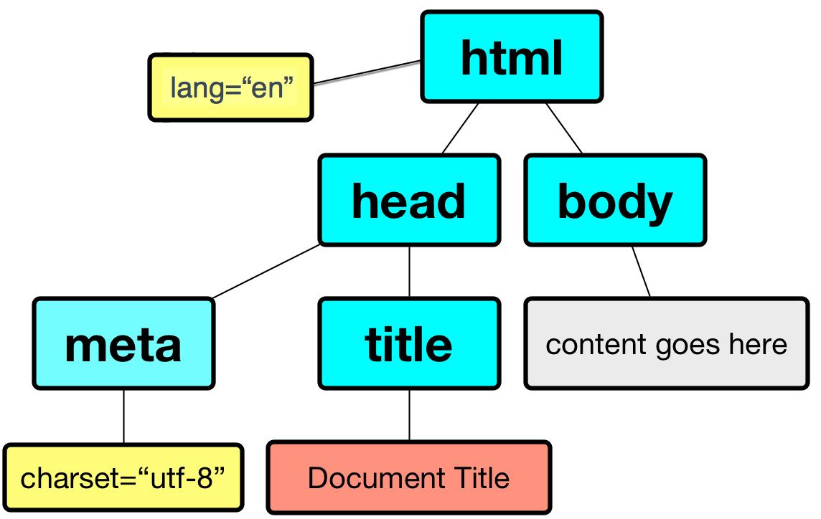
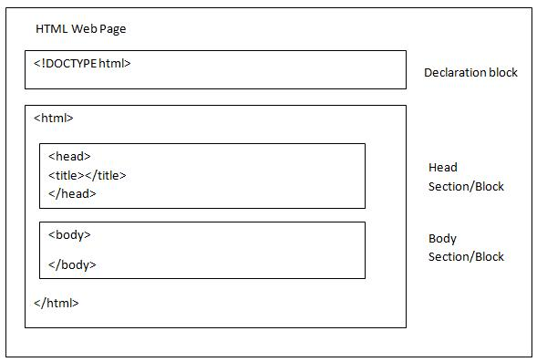
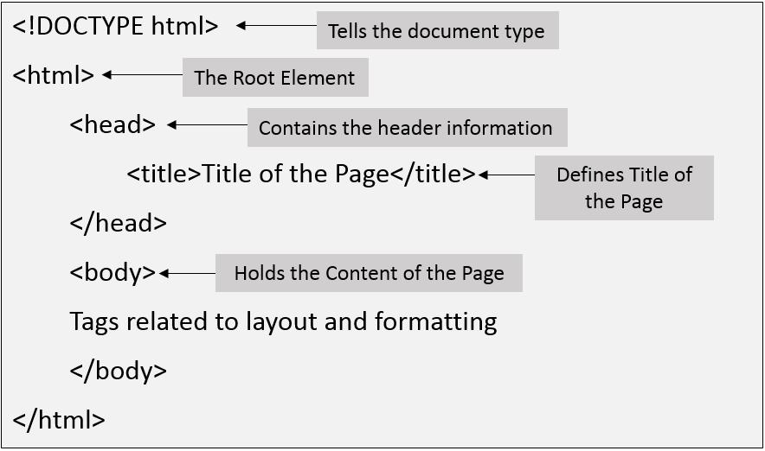

Full Example
# Source: AI Source: Provided by: [Data Path: Persons Table -> ID Column: 1, Name_En Column: Motasem Essam] -> From: [ChatGPT] on [5/6/2026]
A basic HTML document looks like this:
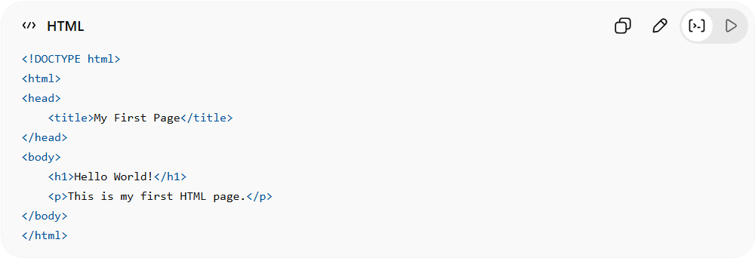
<!DOCTYPE html>
<html>
<head>
<title>My First Page</title>
</head>
<body>
<h1>Hello World!</h1>
<p>This is my first HTML page.</p>
</body>
</html>

Real Example

Create html file
# Source: ScreenShot Source: Provided by: [Persons Table -> ID Column: 1, Name_En Column: Motasem Essam] -> Tool: [Automation Table -> ID Column: 16, Name_En Column: Screen Capture] -> From [Operating System: Windows] on [5/6/2026]
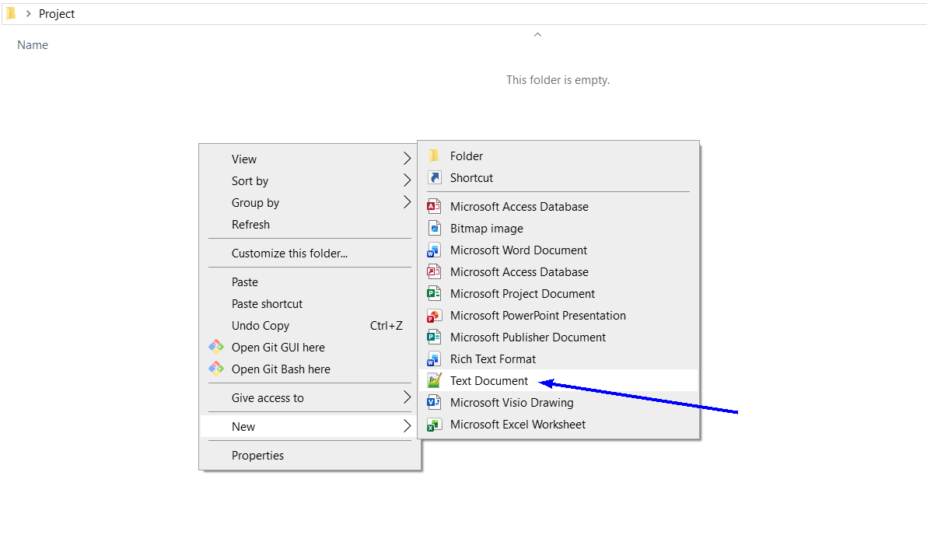
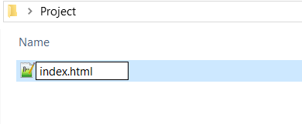
index.html

Open file
# Source: ScreenShot Source: Provided by: [Persons Table -> ID Column: 1, Name_En Column: Motasem Essam] -> Tool: [Automation Table -> ID Column: 16, Name_En Column: Screen Capture] -> From [Operating System: Windows] on [5/6/2026]
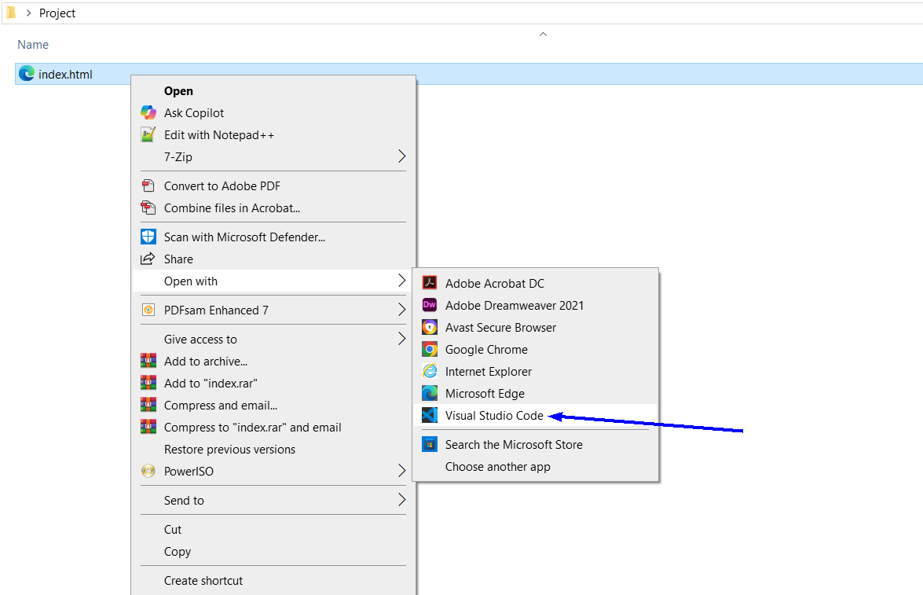
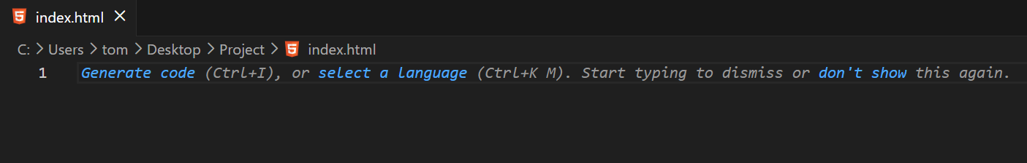

Write Code and Save the file
# Source: ScreenShot Source: Provided by: [Persons Table -> ID Column: 1, Name_En Column: Motasem Essam] -> Tool: [Automation Table -> ID Column: 16, Name_En Column: Screen Capture] -> From [Operating System: Windows] on [5/6/2026]
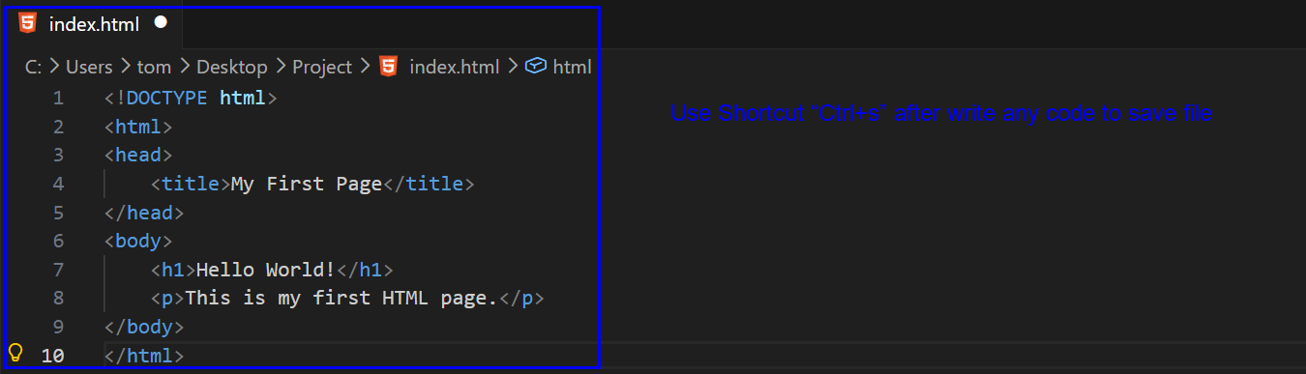
Use Shortcut “Ctrl+s” after write any code to save file
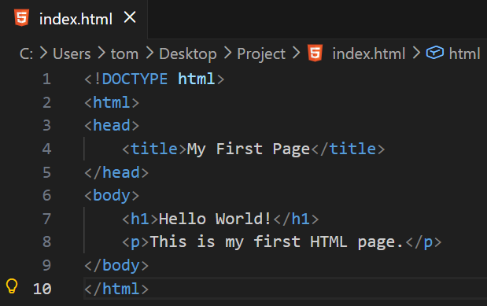
<!DOCTYPE html>
<html>
<head>
<title>My First Page</title>
</head>
<body>
<h1>Hello World!</h1>
<p>This is my first HTML page.</p>
</body>
</html>

Open Page
# Source: ScreenShot Source: Provided by: [Persons Table -> ID Column: 1, Name_En Column: Motasem Essam] -> Tool: [Automation Table -> ID Column: 16, Name_En Column: Screen Capture] -> From [Operating System: Windows] on [5/6/2026]
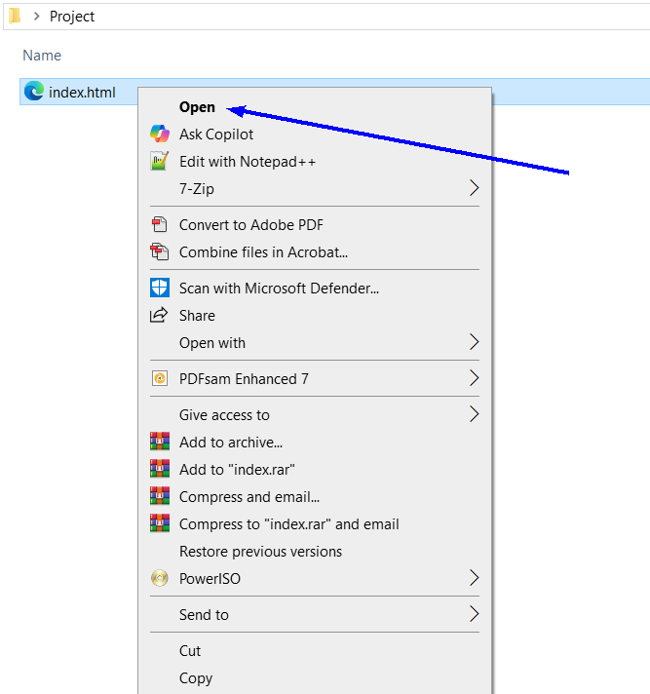
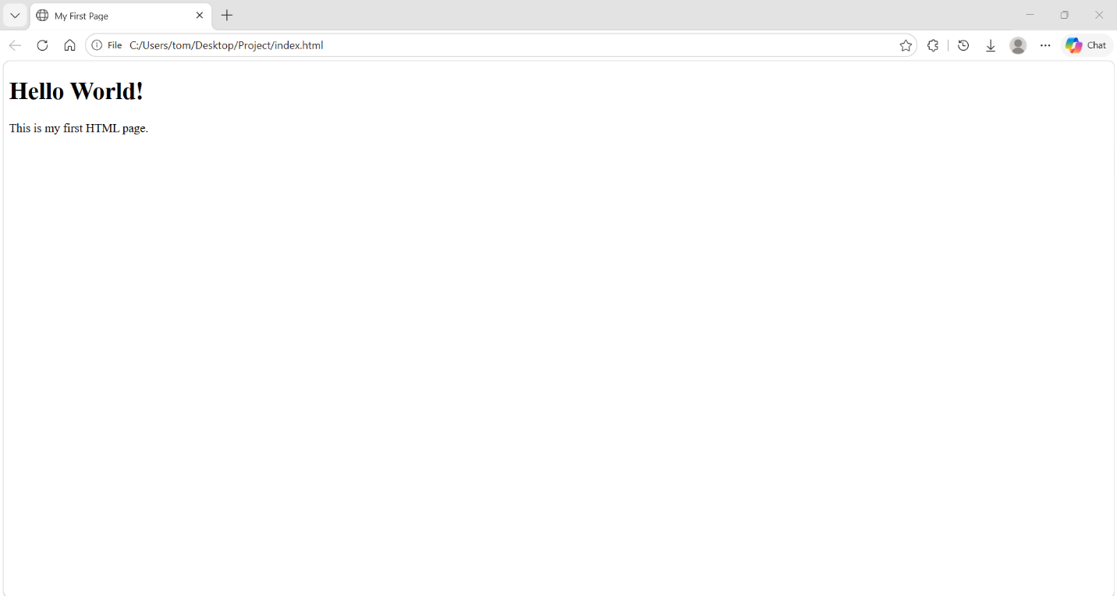

🧠 Simple explanation
# Source: AI Source: Provided by: [Data Path: Persons Table -> ID Column: 1, Name_En Column: Motasem Essam] -> From: [ChatGPT] on [5/6/2026]
Think of an HTML document like:
- 📄 A blueprint of a webpage
- 🏠 A house plan (head = settings, body = content)
- 🖥️ Instructions for the browser to build a page

⚙️ Main parts of an HTML document
# Source: AI Source: Provided by: [Data Path: Persons Table -> ID Column: 1, Name_En Column: Motasem Essam] -> From: [ChatGPT] on [5/6/2026]
- <!DOCTYPE html> → tells browser it is HTML5
- <html> → root of the document
- <head> → contains metadata like title, settings (not visible)
- <body> → visible content on the page
- <h1> → heading
- <p> → paragraph

🌐 Where HTML documents are used
# Source: AI Source: Provided by: [Data Path: Persons Table -> ID Column: 1, Name_En Column: Motasem Essam] -> From: [ChatGPT] on [5/6/2026]
- 🌍 Websites
- 📱 Web apps
- 🖥️ Browser pages
- 📄 Online forms and dashboards

🚀 In short:
# Source: AI Source: Provided by: [Data Path: Persons Table -> ID Column: 1, Name_En Column: Motasem Essam] -> From: [ChatGPT] on [5/6/2026]
HTML Document = a file that contains HTML code used to build and display a web page in a browser.

